Moose International
LCL Web Reference Guide
Chapter
Moose Training
10-23-2020

LCL Web Reference Guide
Table of Contents
Welcome to LCL Web 2
Accessing & Logging into LCL Web 2
Navigating LCL Web 3
Fraternity 4
Fraternal Unit Information 4
Officers - Enter & Edit 5
Local Officers – Enter & Edit 6
Dues Rates 6
Monthly Totals 7
Categories & Activities 8
Pay A/R 10
Members 11
Member Search 11
New Member Promo 15
Pay Dues 15
Applications 18
Search 18
Entry 20
Review Online Applications 21
Reports 22
Officers 22
Officer Labels 23
Deposit List 24
Valued Veterans 25
Financial Transmissions 26
Exports 27
Forms 28
Awards 28
Conference Attendance 29
Form 114 29
Form 166 30
Member Retention 32

Welcome to LCL Web
Moose International’s Membership and IS Departments are excited to introduce you to our new web-based version of LCL.net. The new and improved program will be used to manage your membership records, process applications and run reports without ever needing to transmit. The data is live, meaning it updates to Moose International upon entry. How sweet is that? Read on to learn how to access and navigate within LCL Web. This document reads in the order the features appear on the menu ribbon, from left to right.
Accessing LCL Web
Open a new tab in your internet browser and type www.mooseintl.org to go to the Moose International website.
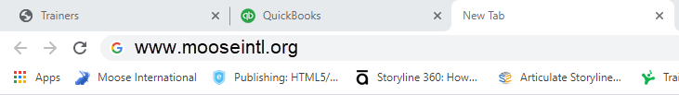

Once on the Home page, click on LCL WEB found in the blue ribbon at the top.
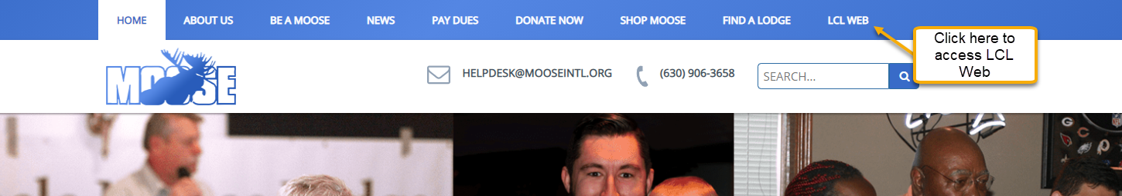
Logging into LCL Web
Just like Admin menu, a Fraternal Unit Passcode is required for log in. Note: Your previous FRU Passcode, that was used to access Admin menu, is no longer valid. Please use the new FRU Passcode assigned to you in the email from Moose International welcoming you to LCL WEB.
When the LCL Web Sign In box appears, enter your MID in the Member ID field, your Last Name, select the Fraternal unit type from the drop-down menu, enter your FRU number, followed by your Fraternal unit passcode. Click Sign In.
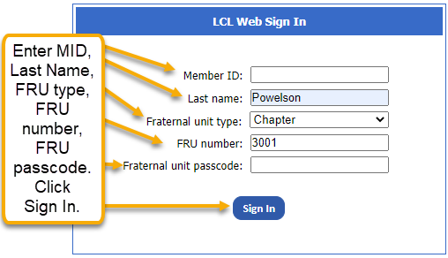
Navigating LCL Web
Once logged in, the program opens to the LCL Web Home screen which displays information specific to your Fraternal Unit, however, the information cannot be edited from this screen.
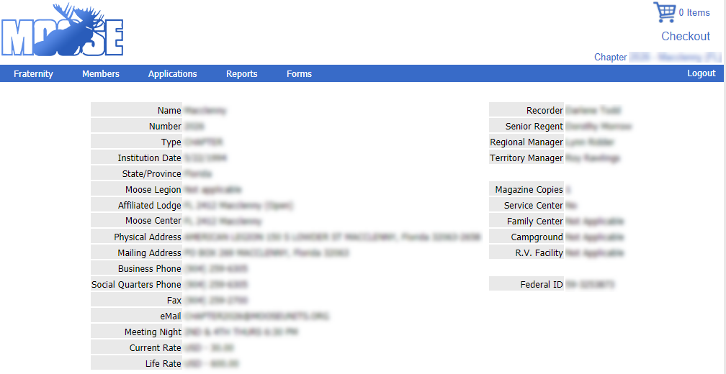
To move throughout LCL Web, use the menu ribbon shown below:
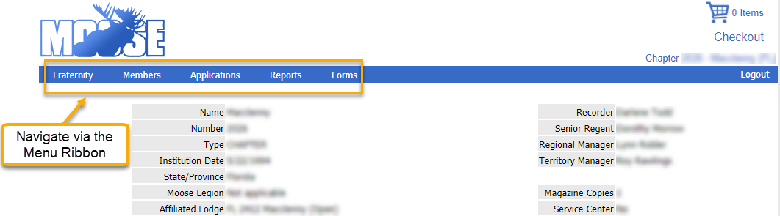
While very similar to Moose Admin, you will notice that there are changes and additions to the ribbon.
When you have applications that are ready to be enrolled, you will get this reminder:
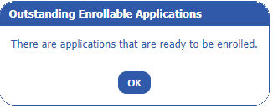
Click OK to continue with your work.

Fraternity – Fraternal Unit Info
To edit FRU Information, click on the Fraternity drop down from the menu ribbon. Choose Fraternal Unit Info. 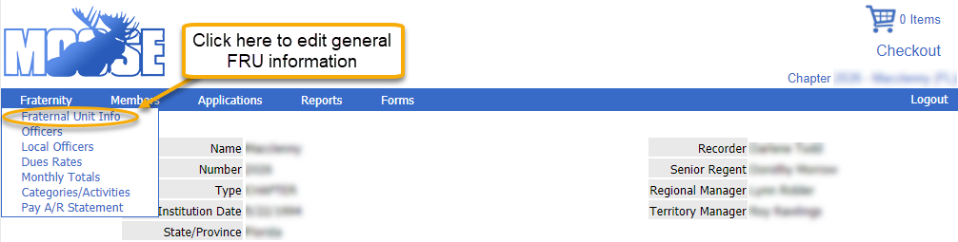
Make necessary edits or changes and click Save.
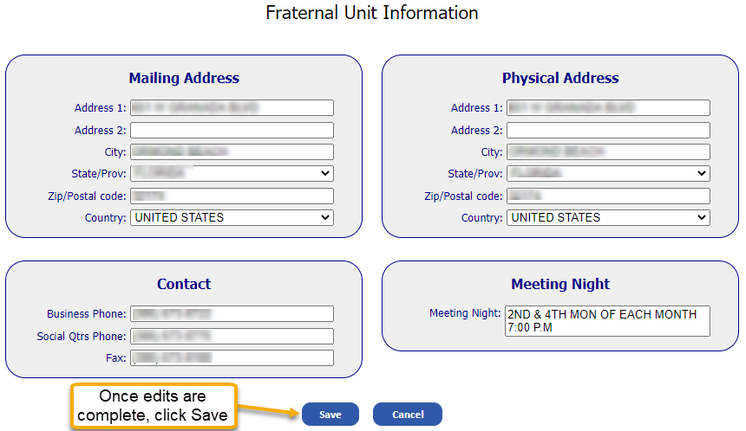

Fraternity - Officers
This feature of LCL Web is used for the entry of new officers and chairman at the beginning of the Moose Fiscal year. It is also used to edit, update or add officers during the year. Choose Officers from the Fraternity drop down menu.
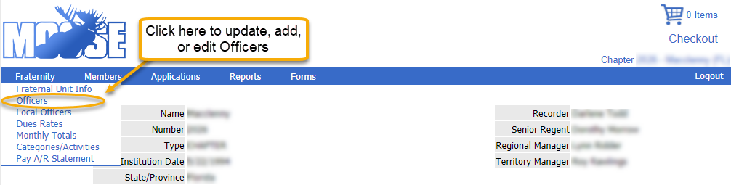
Note: At the start of a Moose Year, do not enter elected officers until the date designated by Moose International.
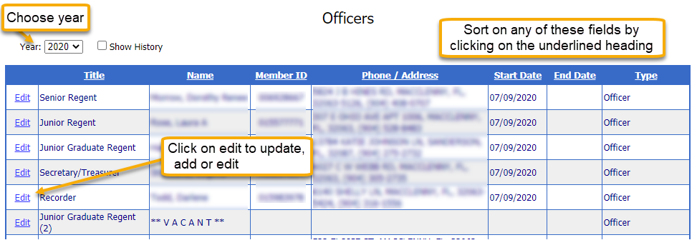
Update, edit or add an officer via this pop-up that appears after clicking on Edit. Only enter an end date for those officers who are leaving mid-term. Once edits, updates and additions have been made, click Save.
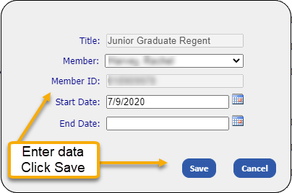

Fraternity – Local Officers
This unique to LCL Web feature, allows you to enter Committee information that is specific to your unit. Click on Add New Office to enter the Chairman and Officers. Enter the Code (something that is memorable to you) and give the Committee a Title, i.e. Lodge Moose Legion Committee. The Code and Title can be the same thing.
Fraternity – Dues Rates
A history of Dues rates for Annual Membership and Life Membership can be seen here. Click Fraternity>Dues Rates.
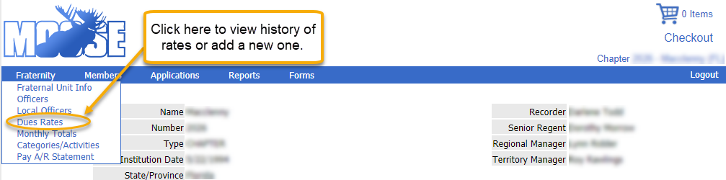
Attempts to edit current Dues Rates will be met with the following error message:
Edits to recently entered dues rates can only be made before the first set of dues renewal notices are sent. However, rate additions are made here by clicking on Add New Rate. Just enter Total Amount and the Moose International and Fraternal Unit Amount will be auto-calculated. Click Save. Please refer to the General Laws regarding requirements for adding new rates.
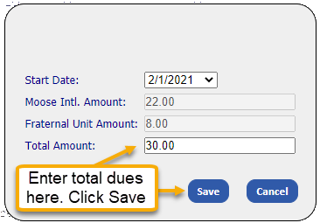
Fraternity – Monthly Totals
Click on Monthly Totals to view your unit’s current fiscal year monthly totals for Active Members, Expired Members and Dropped Members.
Click on the down arrow in the Fiscal Year field to view totals from previous Fiscal years.
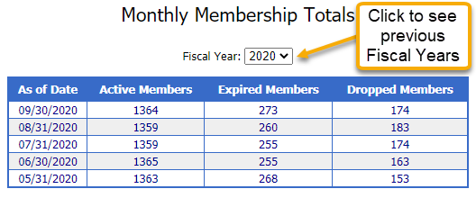

Fraternity – Categories/Activities
Click on Categories/Activities to add or view categories and activities that are important or popular to your members and your unit.
Note: No entries will be found upon first going live in LCL Web. Any activities entered on membership records in LCL.net do NOT transfer to LCL Web. The categories and activities will need to be re-entered and then added to member records where appropriate. Run a report of your LCL.net activities for entry into LCL Web, if desired.
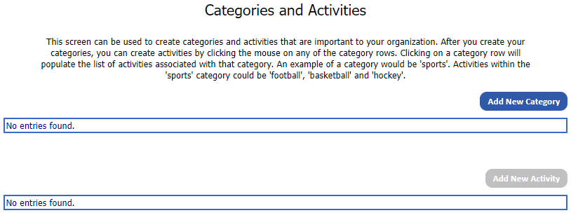
Click on Add New Category to enter a category.
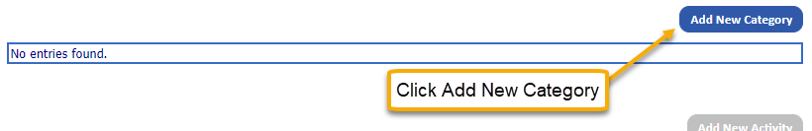
Enter the Category, then add Description. Both fields must be filled. Click Save.
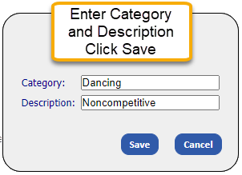
Once the categories have been established, activities associated with that category should be added. For example, if you add the category “Dancing” you may want to add activities such as “Line Dancing,” “Polka,” “Swing,” etc. Once these categories and activities have been established, they can be added to individual member records allowing for easy reporting of members’ interests.
Click on the category for which the activity is to be added. Then click on Add New Activity. Click Save.
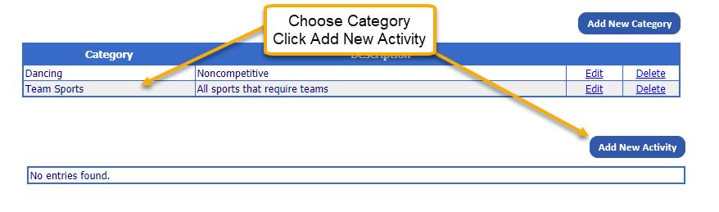
Enter Activity, click Save.
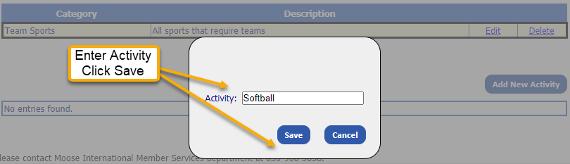

Fraternity – Pay A/R Statement
You may use LCL Web to quickly access your Statement of Account (Accounts Receivable) balance and payment information. You may also choose to make your payments this way rather than sending a check to Moose International. Click on Pay A/R Statement.
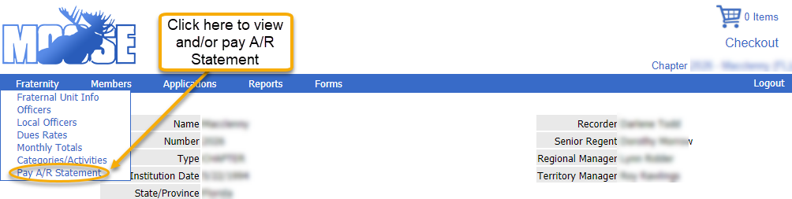
The screen that appears will supply the balance due and most recent payment information. Note: The previous payment will not display until the first payment is made after going live in LCL Web.
Account balances may be conveniently paid via Credit card or bank account. Enter the dollar amount you wish to pay in the Payment Amount field. Use the Payment Notes field to provide any important information to Moose International about your payment. This field is optional and may be left blank. Click Add to Cart.
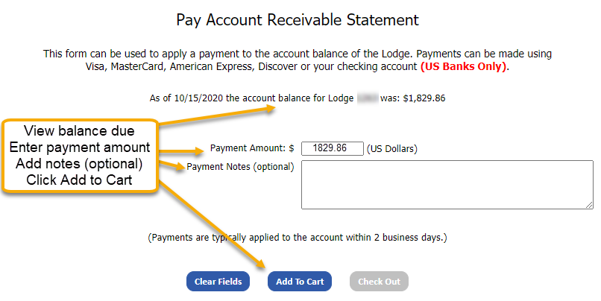
After clicking Add to Cart, the Payment Amount field will be blank. Click Check Out or the Shopping Cart to continue to make payment.

You will see a screen showing what is in your shopping cart. From this screen you may choose to: Remove All Items from Cart or Proceed to Checkout. If the payment information showing is correct, click Proceed to Checkout.
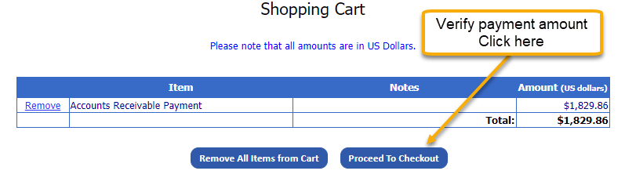
Enter information in the following fields: Name, Address ,City, State, ZIP Code. Click Payment Type and choose Checking Account, to pay by electronic check or Credit Card to pay by Mastercard, Visa, American Express or Discover.
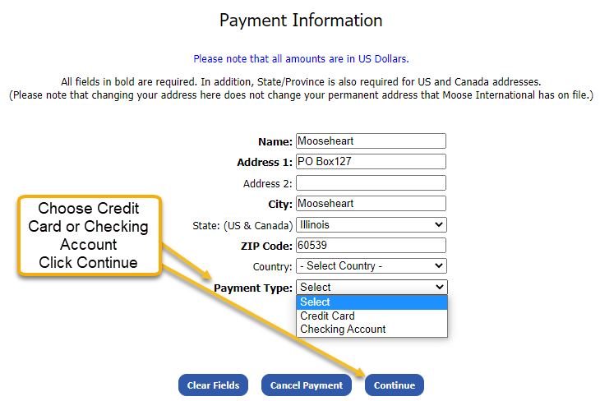
Follow instructions to enter Checking account or Credit Card Information and click Continue. From the Confirmation screen, you may Cancel Payment, Update Payment Method, Edit the Shopping Cart to add or remove items and finally, Submit Payment. Click the Print Receipt button for your records.

Members – Member Search
Member Search can be used to search for members of your FRU. Click on Members>Member Search.
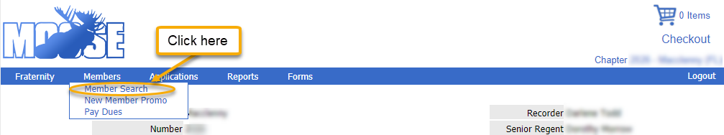

You may search by Member I.D. or name. Search Based on Member I.D.: Enter the MID in Member ID field. Click Search.
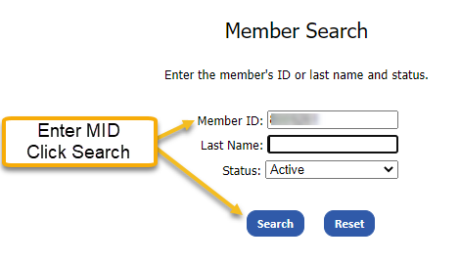
Given a valid member ID within your FRU, the following results will display. Membership details can be viewed by clicking Select.
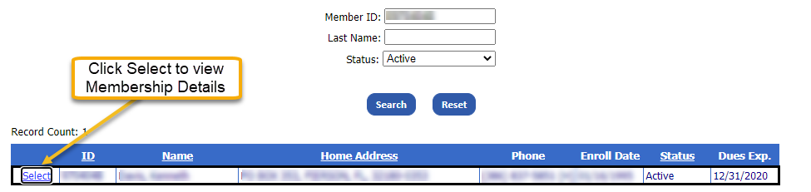
Search Based on Member Name - Any combination of last name and status may be used to search. You may use incomplete names if you are unsure of the spelling. Enter partial name, initial or full name in Last Name field. Use the drop down menu to choose one of the following status types: All, Active or Inactive. Click Search.
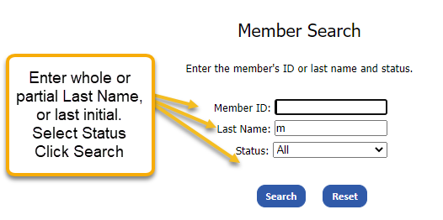
In the example below a partial last name was entered, with the status All. Every member with a last name starting with m is listed, regardless of status. Once the desired member is located, the record can be viewed in more detail or edited by clicking Select.
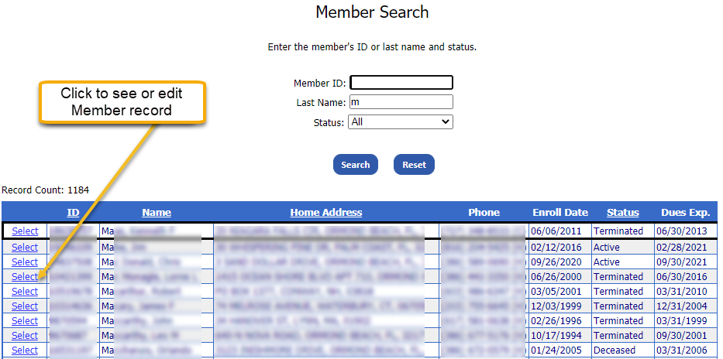
Once in a member’s record, all white fields are editable. Click in the appropriate field to make edits. New to LCL Web is the ability to identify a member as a Valued Veteran. Simply click the Valued Veteran box. Please note: the program remains the same. Clicking the Valued Veteran box will NOT result in Valued Veteran membership cards being sent. They will be mailed at the time of renewal. Additionalyy, certificates and pins are mailed annually.
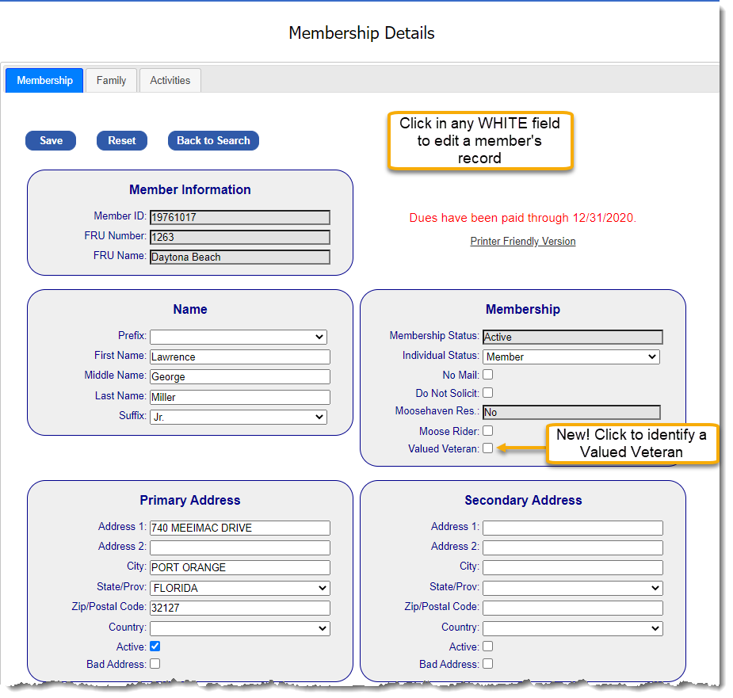

Reports showing a member’s Sponsor, Officer, Training, Payment and Membership histories can be viewed by clicking the link below the desired history.
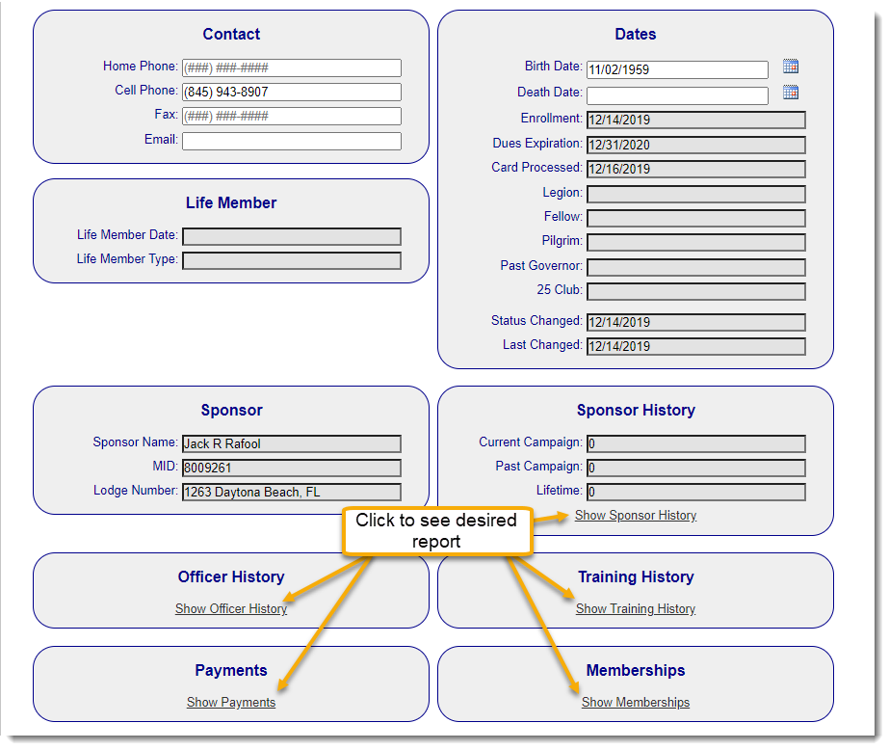
For those members who have not been an officer, attended training, made payments or sponsored a member you will receive the message, “No Data Found.” However, if no report or No Data Found message appears, disable your Pop-up Blockers in your browser settings to allow the report.

Members – New Member Promo
This feature of LCL Web is used for temporary promotions. No instruction will be given at this time. Should you ever have questions about how to use this portion of LCL Web, call the Training Department at 630- 966-2294.
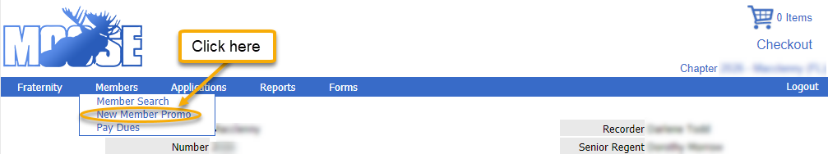
Members – Pay Dues
Easily view a list of all expired members and those whose dues will expire within the next 60 days by clicking Members>Pay Dues.
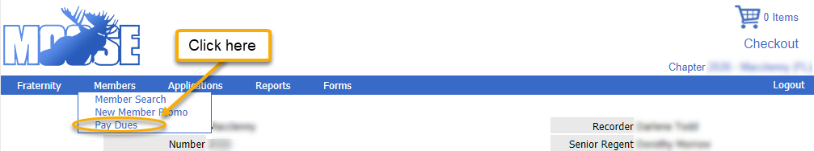
You may pay up to 15 members’ dues at one time through LCL Web. From the list created when Pay Dues was clicked, click Add To Cart for each of the members for whom you wish to pay dues. Each selected member will be highlighted in blue and will read In Cart.
If more than 15 members are selected you will get the following error message:
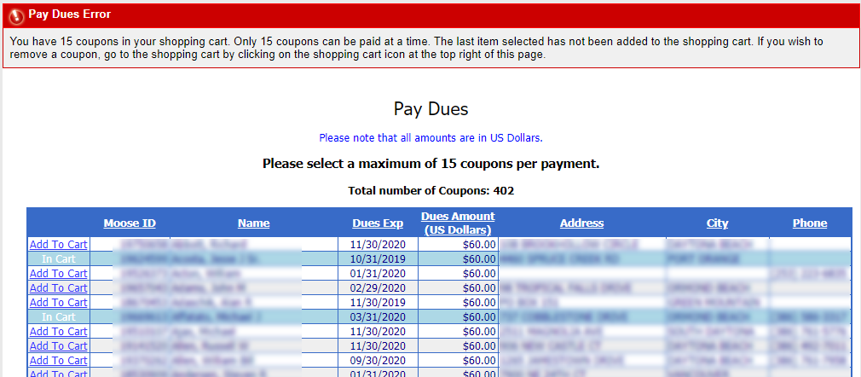
To remove unwanted items from the cart or to continue the payment process, click on the shopping cart icon, shown at the top right of the screen.
A list of all items in your shopping cart will appear with the following options:
View Coupon – by choosing this option, you will see the payment details for the member chosen, including Coupon #, Expiration Date, Dues for each unit to which the member belongs, Total Dues Due and a Renewal Mailing Address.
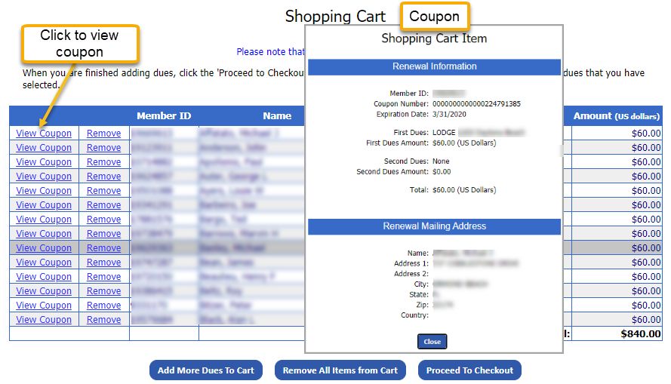
Remove –allows you to remove one member at a time from the shopping cart. Add More Dues to Cart – this feature allows you to go back to the list of renewals and add more to the cart, if you have less then 15 selected. Remove All Items from Cart – by clicking here you will clear out the shopping cart in its entirety. Proceed to Checkout – click here when ready to complete the payment process.
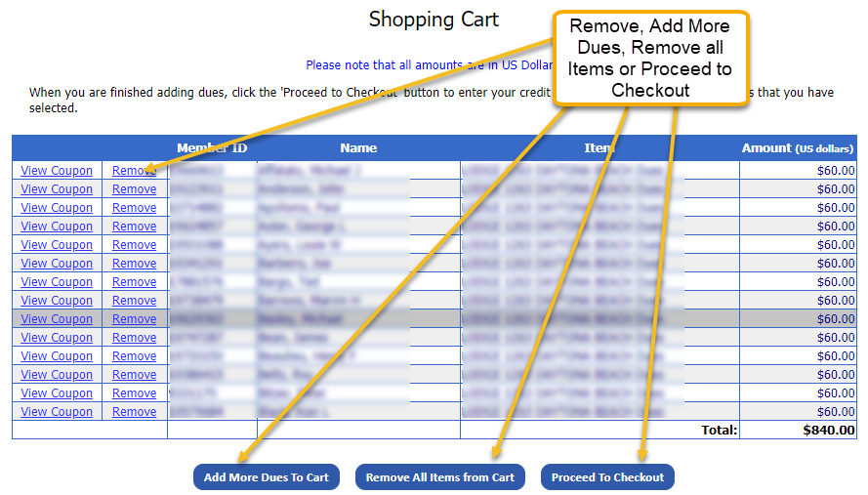

Click on Proceed to Checkout when you are ready to make payments for the items in your cart.You must enter information in the following fields: Name, Address 1, City, State, ZIP Code, and select Payment Type. (Credit Cards are the only type of payment available for payment of dues.) Finish the payment process by entering information in the following fields:Card Type, Credit Card Number, Expiration Date. Click Continue.
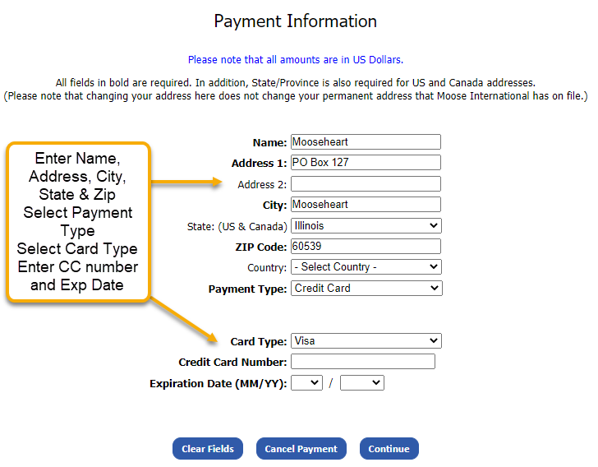
You will be routed to a payment confirmation screen. You may choose to: Complete payment by clicking Submit Payment,Cancel payment by clicking Cancel Payment, Change your credit card information by clicking Update Payment Method, Remove/Add members for whom you are submitting payment by clicking Edit Shopping Cart.
Once you have confirmed that all of the information shown is correct, to complete the payment, click Submit Payment.
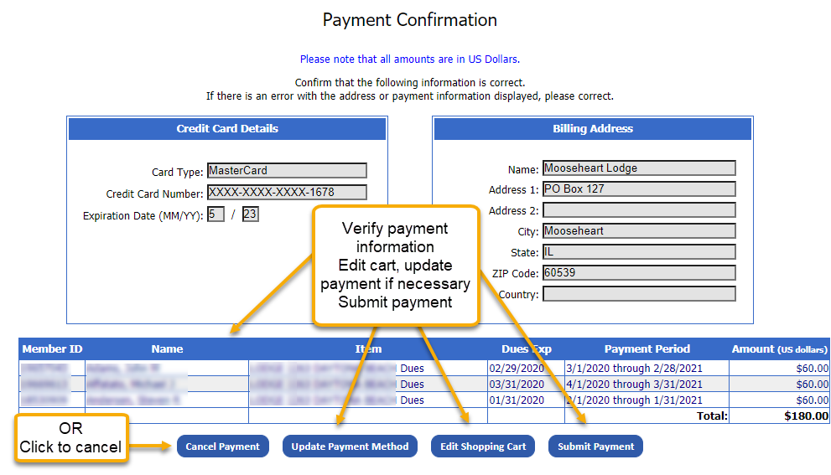
Click the Print Receipt button for your records.
Applications – Search
LCL Web makes it easy to search for applications. Click on Applications>Search.
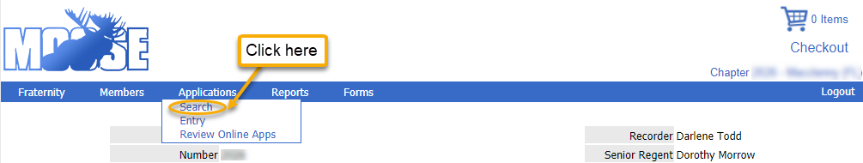
Searches can be made based upon Member ID, Last Name or Status. Click Search.
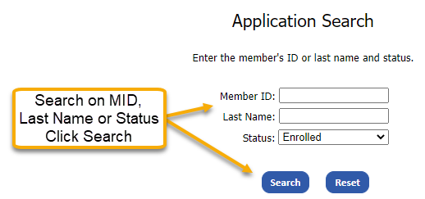

The Results page will show all applications meeting the search criteria. The applications can be sorted by Application Number, Applicant Name, Type, Status, MID, Application Date or Accepted Date by clicking the underlined column heading. Click Select to the far left of the application you wish to view.
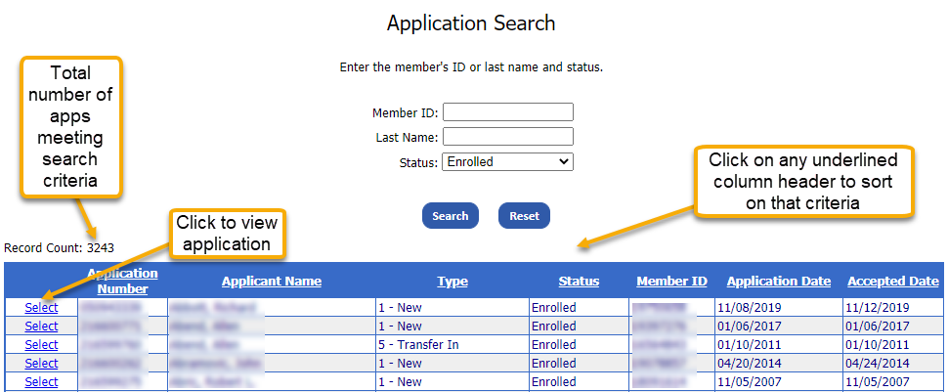

All information originally entered will appear on this screen. Note: All fields and buttons are greyed out, other than Back to Search. There is no option to edit or delete from here.
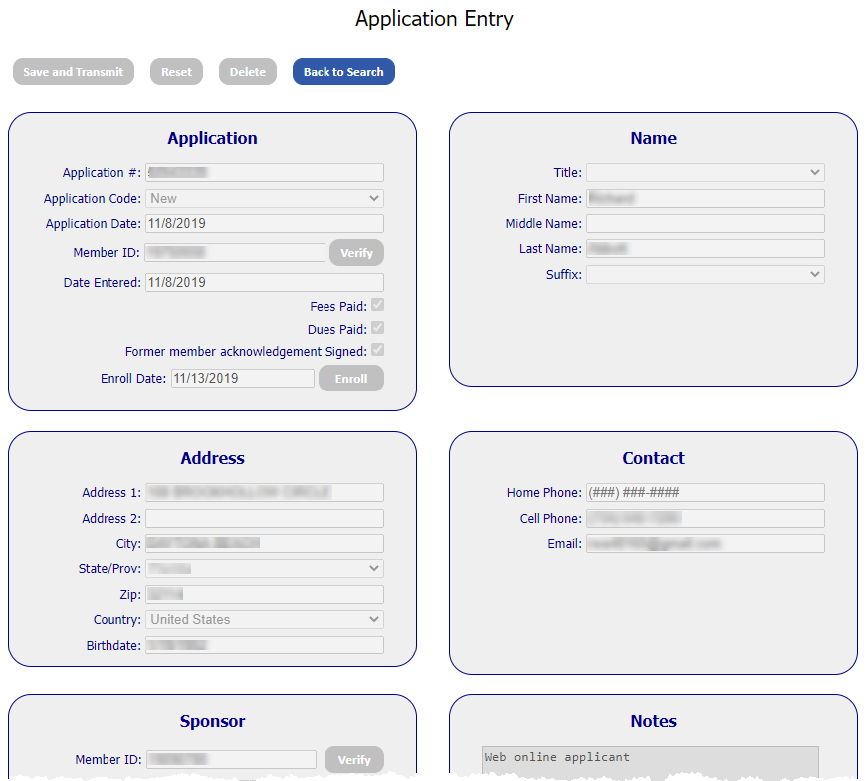

Note: Only transmitted applications (on the day of entry) can be edited.

Applications – Entry
Enter membership applications by clicking on Applications>Entry.
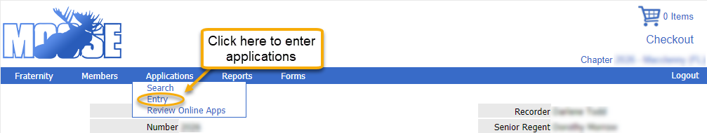
Select the Application Code from the drop-down menu: New, Mulitmember, Re-Enroll, Reinstate or Transfer In. Based on this, all required fields will appear white. Use the prospective member’s application to complete the Application, Name, Address, Contact, and Sponsor boxes. The Notes box is for messages from MI. Click Save and Transmit.
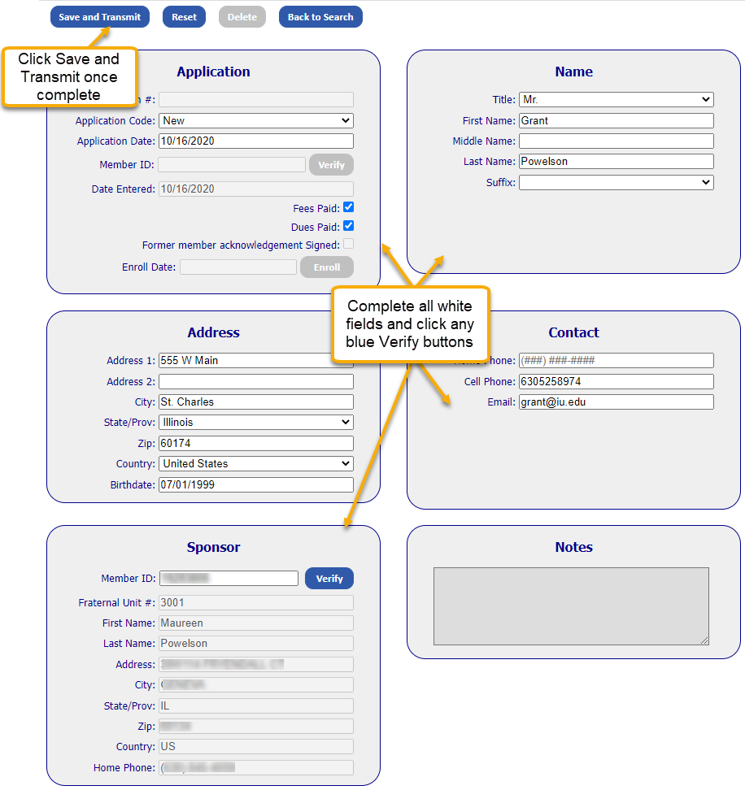
Applications – Review Online Apps
Review your unit’s online applications by clicking Applications>Review Online Apps.
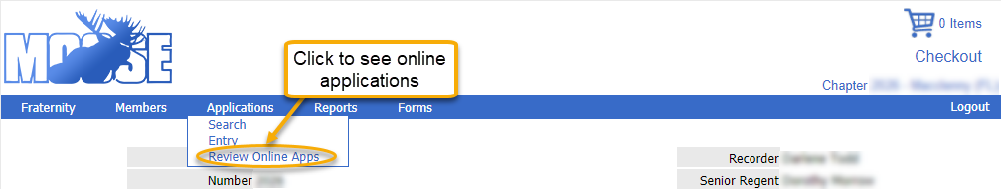
When your unit does not have any online applications to review, the following message will appear.
Recently submitted online applications that appear on this screen must be processed to be sent to Moose International. Click on the Action drop-down menu. Choose Process. Click Save. The nightly sweep will pick up applications that have been processed. The following day, all error free applications will appear as Accepted. Once approved, the next step, like any application is to be enrolled.
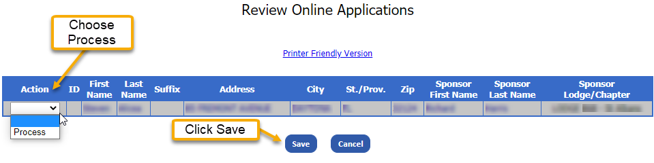
Reports
From Reports, run officer, chairmen, and appointed officer reports; create labels sorted by name or zipcode; see the most recent deposit history from Moose Intl.; identify which of your members are Valued Veterans; see a history of your unit’s financial transmissions; and export reports.
Reports – Officers
Run reports of current year officers, appointed officers, chairmen. Labels, of various sizes, for these groups can also be produced through this menu item. Additionally, there is an option to create zip code counts. Click on Reports>Officers.
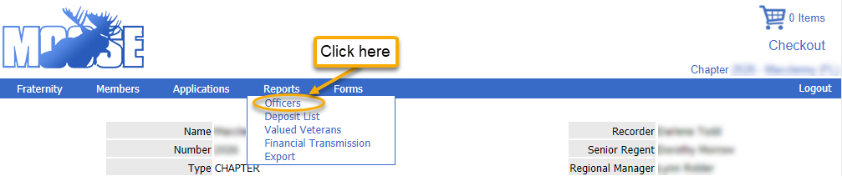
Choose All, Officers, Chairman or Appointed Officers from the Officer Type drop-down menu. Click Create Report.
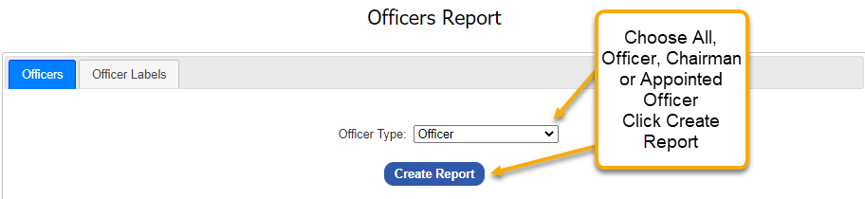
Note: If you have pop-up blockers enabled, you will get the following message:
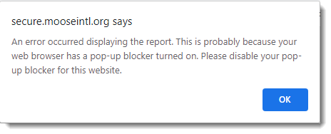
To disable, go to your browser settings. Pop-up blockers are found in the Privacy and Security section in Google, under Site Settings. Click the arrow next to Pop-ups and redirects; toggle to off. Once disabled, your data will appear as a .pdf which can printed, or downloaded & saved.
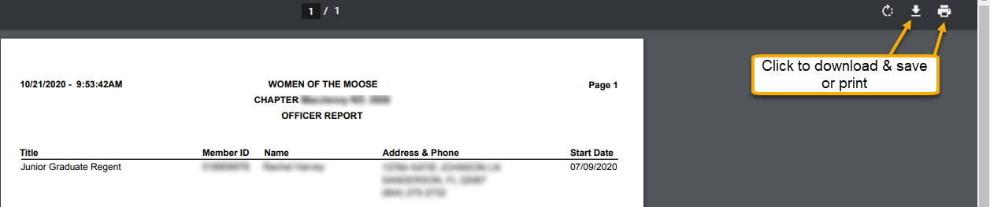
Note: You may want to enable Pop-up blockers once reporting is complete.
Create labels by clicking the Officer Labels tab. Click on the Officer Type drop down menu to choose the group for which you wish to create labels. You may choose from All, Officer, Chairman or Appointed Officer just as with the report feature. Labels may be sorted by Name or Zip Code by clicking on the Sort drop down menu. Next, choose the type of labels you would like to print by clicking on the Label Selection drop down menu. You may choose from: Laser – Avery 5260, One Up – Avery 4013, Badges – Avery 5395, or Zip Code Report. Click on the Create Report button.
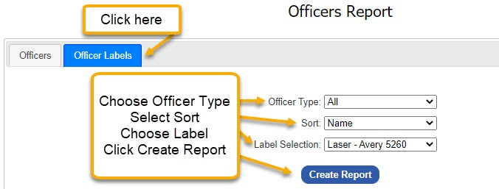
The labels will be in a .pdf format, ready for print. Click on the print icon found at the top, the same as with the report.

Reports – Deposit List
It is critical to the accurate maintenance of your unit’s QuickBooks account that you record your Moose International Membership Dues Pay Outs or Deposits. LCL Web features a Deposit List that is updated weekly. The list contains all deposits made to your FRU, including previous years. Each deposit shown in the list can be viewed for specific details. Click Reports>Deposit List.
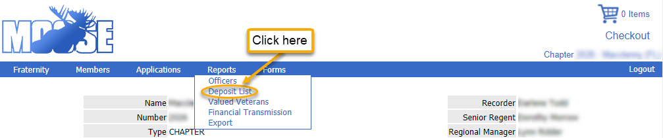
A screen displaying the last 20 Membership Dues Pay Outs will be shown. Additionally, earlier deposits can be viewed by clicking on the page numbers at the bottom.
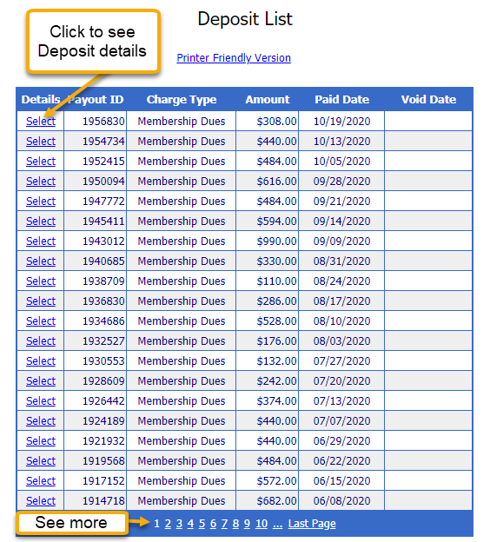
Click Select to see the details of a specific deposit.

Each member for whom your unit is receiving a Dues Pay Out is listed in the Deposit Detail. To print an easy to read version of the Deposit Details or the Deposit List, click Printer Friendly Version. Click Return to Deposit List to return to the deposit history.
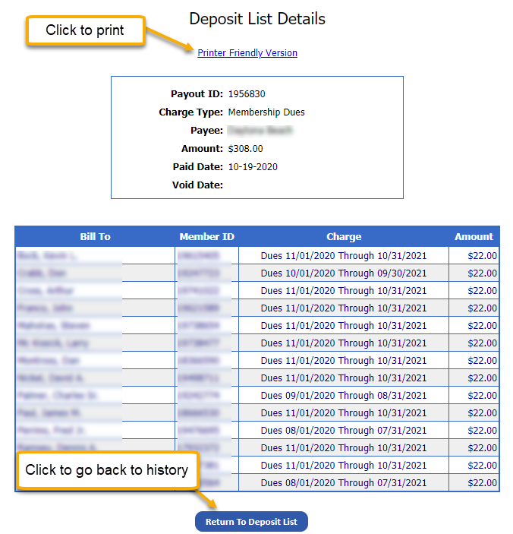
Reports – Valued Veterans
Valued Veterans is a program for veterans of all branches of the U.S. Armed Services as well as those of foreign countries. Members may self-identify as a Veteran and become a Moose Valued Veteran through My Membership Record or by calling the Moose International Help Desk. To view a report of your FRU’s members who have identified as Valued Veterans: Click Reports>Valued Veterans.
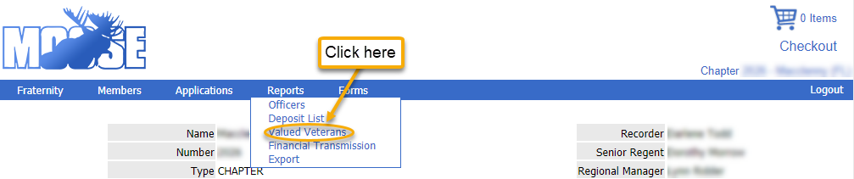

A list of Active Valued Veterans will appear. You have the option to report on other statuses: Active, Deceased, Dropped, Expired, or Terminated by clicking on the Status drop down menu.To create a report that will print in an easy to read format, click on Printer Friendly Version. Sort on any of the information by clicking on the column headings.
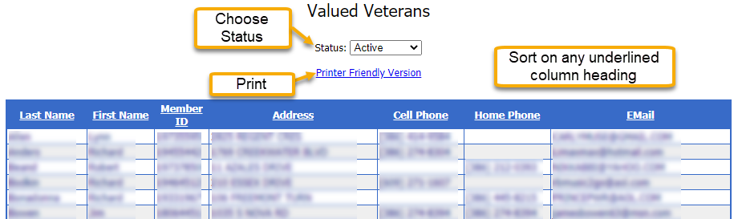
Note: LCL Web now allows for Valued Veteran identification in the member record. See Members – Member Search.

Reports – Financial Transmissions
LCL Web allows you to generate a report of your FRU’s monthly financial transmissions. The report will supply you with the dates that your monthly reports were transmitted to Moose International. Note: Units working in LCL Web will no longer transmit financial reports via LCL. QuickBooks Financial Reports will be emailed to Moose International by the 15th of each month. Click Reports>Financial Transmissions.
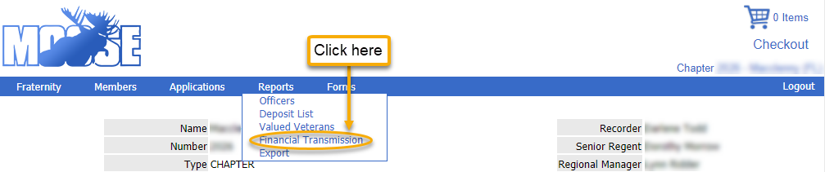

A history dating back two Moose Fiscal Years will be displayed.
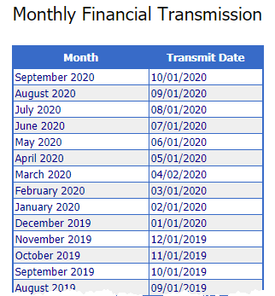
Reports – Exports
This feature of LCL Web is used to run FRU reports. Click Reports>Exports.
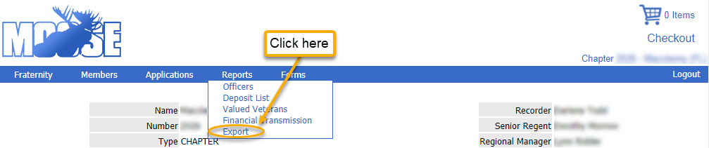
Choose the information or data needed by clicking all applicable items found in Member Fields, or click Select All. Click Add. The order of the Report Fields can be changed by clicking the box to the left of the field and then clicking the Move Up or Move Down button. Fields can also be removed by clicking the box next to the item and then Remove. Choose one or more Member Status to be reported by clicking on the box to the left of the status. Leave Export Options as their default settings. Click Export Data to download the report as an Excel Spreadsheet.
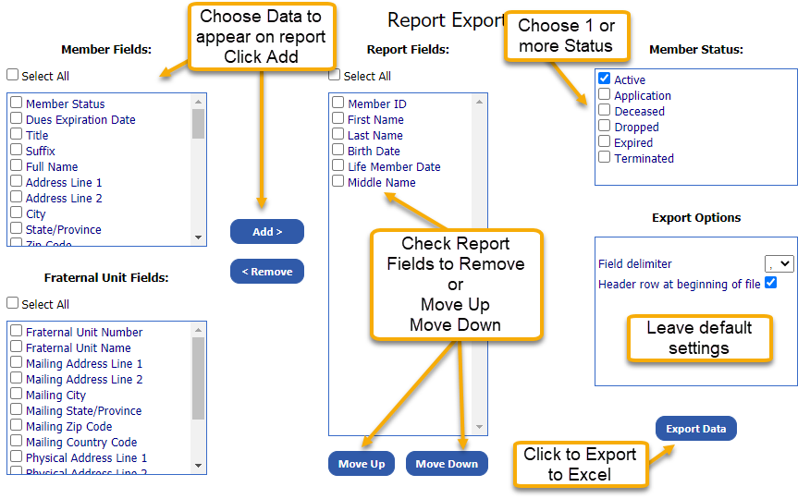
Note: The only way to print the report is to open the downloaded file in Excel. From there, the data can be sorted and manipulated any way you like. Here is a link for information on sorting data in Excel:
https://support.microsoft.com/en-us/office/sort-data-in-a-range-or-table-62d0b95d-2a90-4610-a6ae-2e545c4a4654

Forms
The options found under the Forms drop down menu allow your unit to view, and/or create and submit required forms to Moose International. The following WOTM forms are available though the Forms drop down menu : Awards – Co-Worker of the Year; Conference Attendance (view only); Form 114 (view only); Form 166; and Member Retention.
Forms – Awards
Click on Forms>Awards.
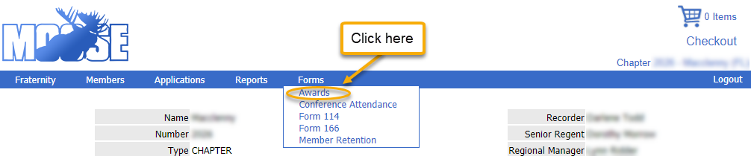
This section of LCL Web is where recorders are to enter the recipient for their chapter Co-Worker of the Year award to Moose International. To enter your chapter’s Co-Worker of the Year nominee: Select the current year Co-Worker of the Year from the Award drop down menu. Select the recipient from the Member drop down menu. Click Save to submit your Co-Worker of the Year recipient to Moose International.
Note: These awards will only appear in the drop down menu during the time frame in which nominations may be submitted.

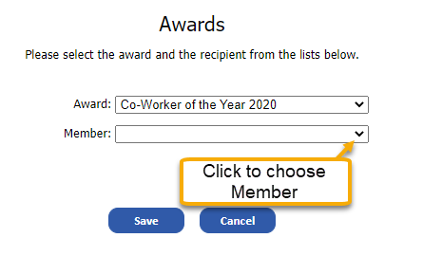

Forms – Conference Attendance
The dates that the chapter attendance was recorded for both the Midyear and Annual Conference can be viewed.
Click on Forms>Conference Attendance
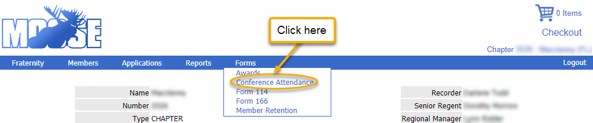
Click the down arrow next to Fiscal Year for the year you wish to see – back to 2010.
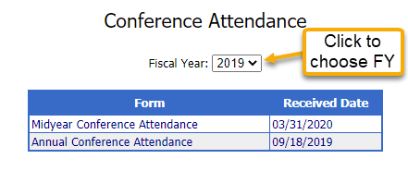
Forms – Form 114
It is the responsibility of the Senior Regent to send the Chapter’s Form 114 and proper checks immediately following the second meeting of the month. The dates each of the thirteen monthly 114 reports were received by Moose International can be viewed in LCL Web.
Click on Forms>Forms 114
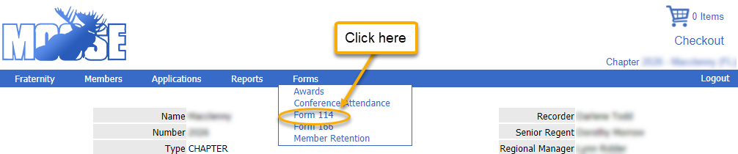
Previous fiscal years can also be veiwed by clicking the down arrow next to Fiscal Year.
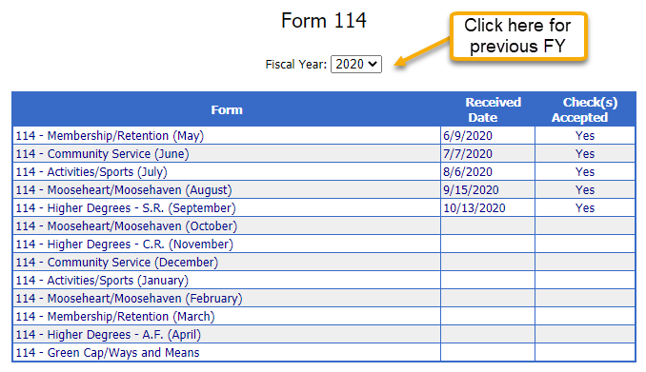
Forms – Form 166
Completion of Form 166 via LCL Web is a requirement for all chapters regardless of money raised.
Click Forms>Form 166
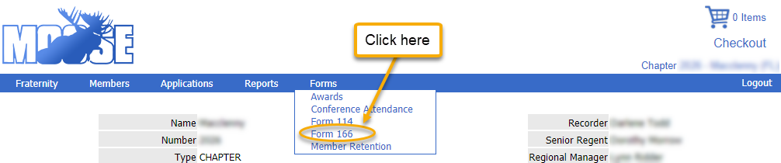

From this screen you may choose the appropriate Fiscal Year by clicking on the down arrow next to the field. Reports may be viewed, by clicking View or completed by clicking Create to the right of the appropriate monthly report.
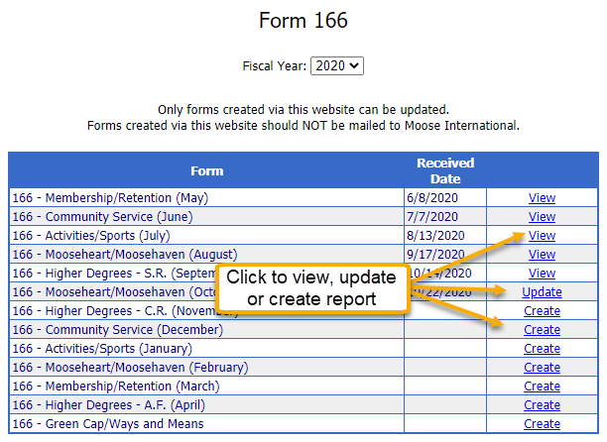

When completing Form 166, the Committee Name will be auto-filled based upon the report you are working in. Enter the Chairman’s Name, Number of Committee meetings held, and the Committee Fund-Raising Project. When an event was held and funds were raised, please enter the details including: Starting date of the event, Ending date of the event, Place held, Number of Committee members present at Fund-Raising Project, Proceeds, Expenses, Profit and click Calculate. Next, indicate how the proceeds shall be distributed, including the amount. Finally enter the Recorder and Senior Regent Names and Phone Numbers. Click Save. Once you have saved, the report is available for updates for the entire Moose Fiscal year. Click Update to make changes, additions or deletions to the report.
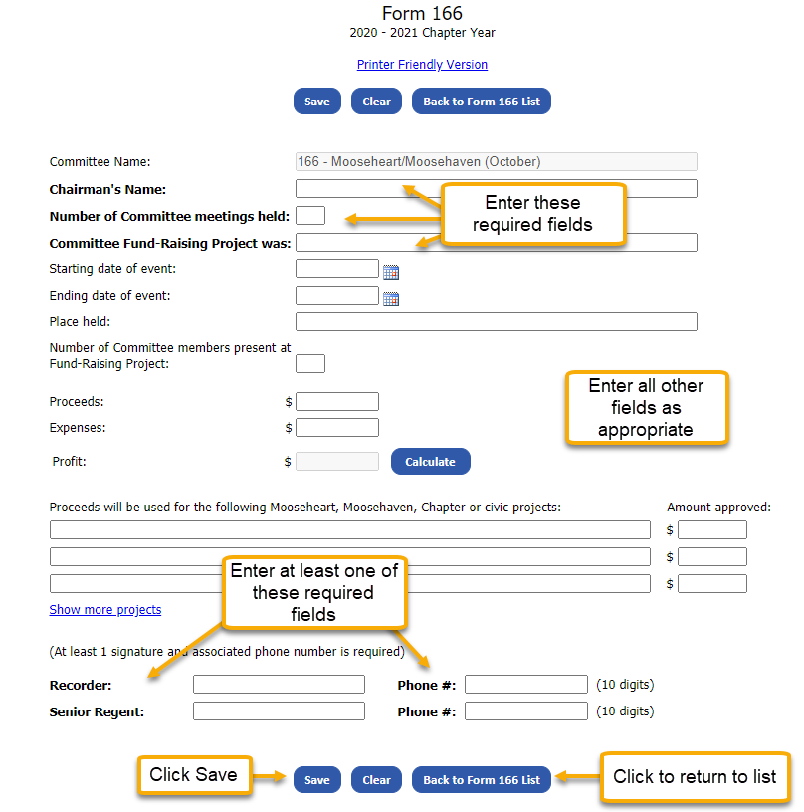
Forms – Member Retention
The first week of November is typically designated as Member Retention Week by Moose International. Each FRU is encouraged to actively participate in this fun, event-filled, week long push to retain members. Moose International wants to hear about your exciting week and learn all of the details of your special events. The best way to share your activities and results is to complete the Member Retention Week Survey. This an electronically submitted survey accessible on LCL Web for a limited time after Member Retention Week ends each year – don’t delay!
Click Forms>Member Retention
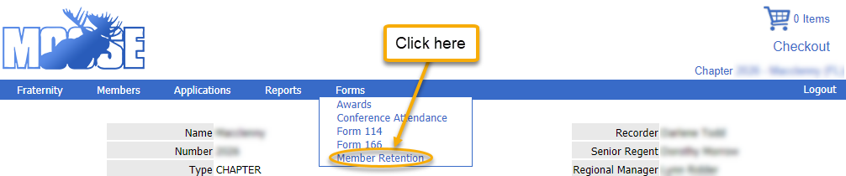

When the form is available, click Create found to the right of the appropriate survey.
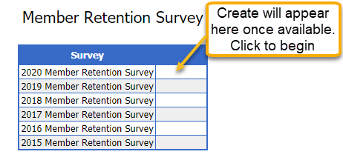
Enter the Membership Committee Chairman’s name and phone number. For each day of Member Retention Week, describe the event or activity that your lodge held, detail the results, the number of volunteers that participated and the number of participants. Once you have entered the specifics for each event, please provide some summary information. Check the radio button for “Yes” or “No” for the Overall Success statement. In the space provided, describe the event your lodge held that you found to be the most successful. Please share any suggestions you have regarding Member Retention Week in the Suggestions box. Click Save and Submit.

